Public Community Discovery

Users  - Primary  - Community manager  - Secondary | Phase 1
Intended Outcome
- Organizers create their community profile as they want their communities to become visible to outsiders and prospective members.
Links
- Figma
- …
- …
- …
- …

Introduction
One of the community organizers we invited to try Kolavo ended up leaving after registration and saying that he wanted to see communities in it before creating his own. This seems he did not have the motivation of creating his community profile because he did not know what it would look like. Therefore, we want to motivate community organizers to create their community profiles by making community lists visible to the public.

Product Requirement
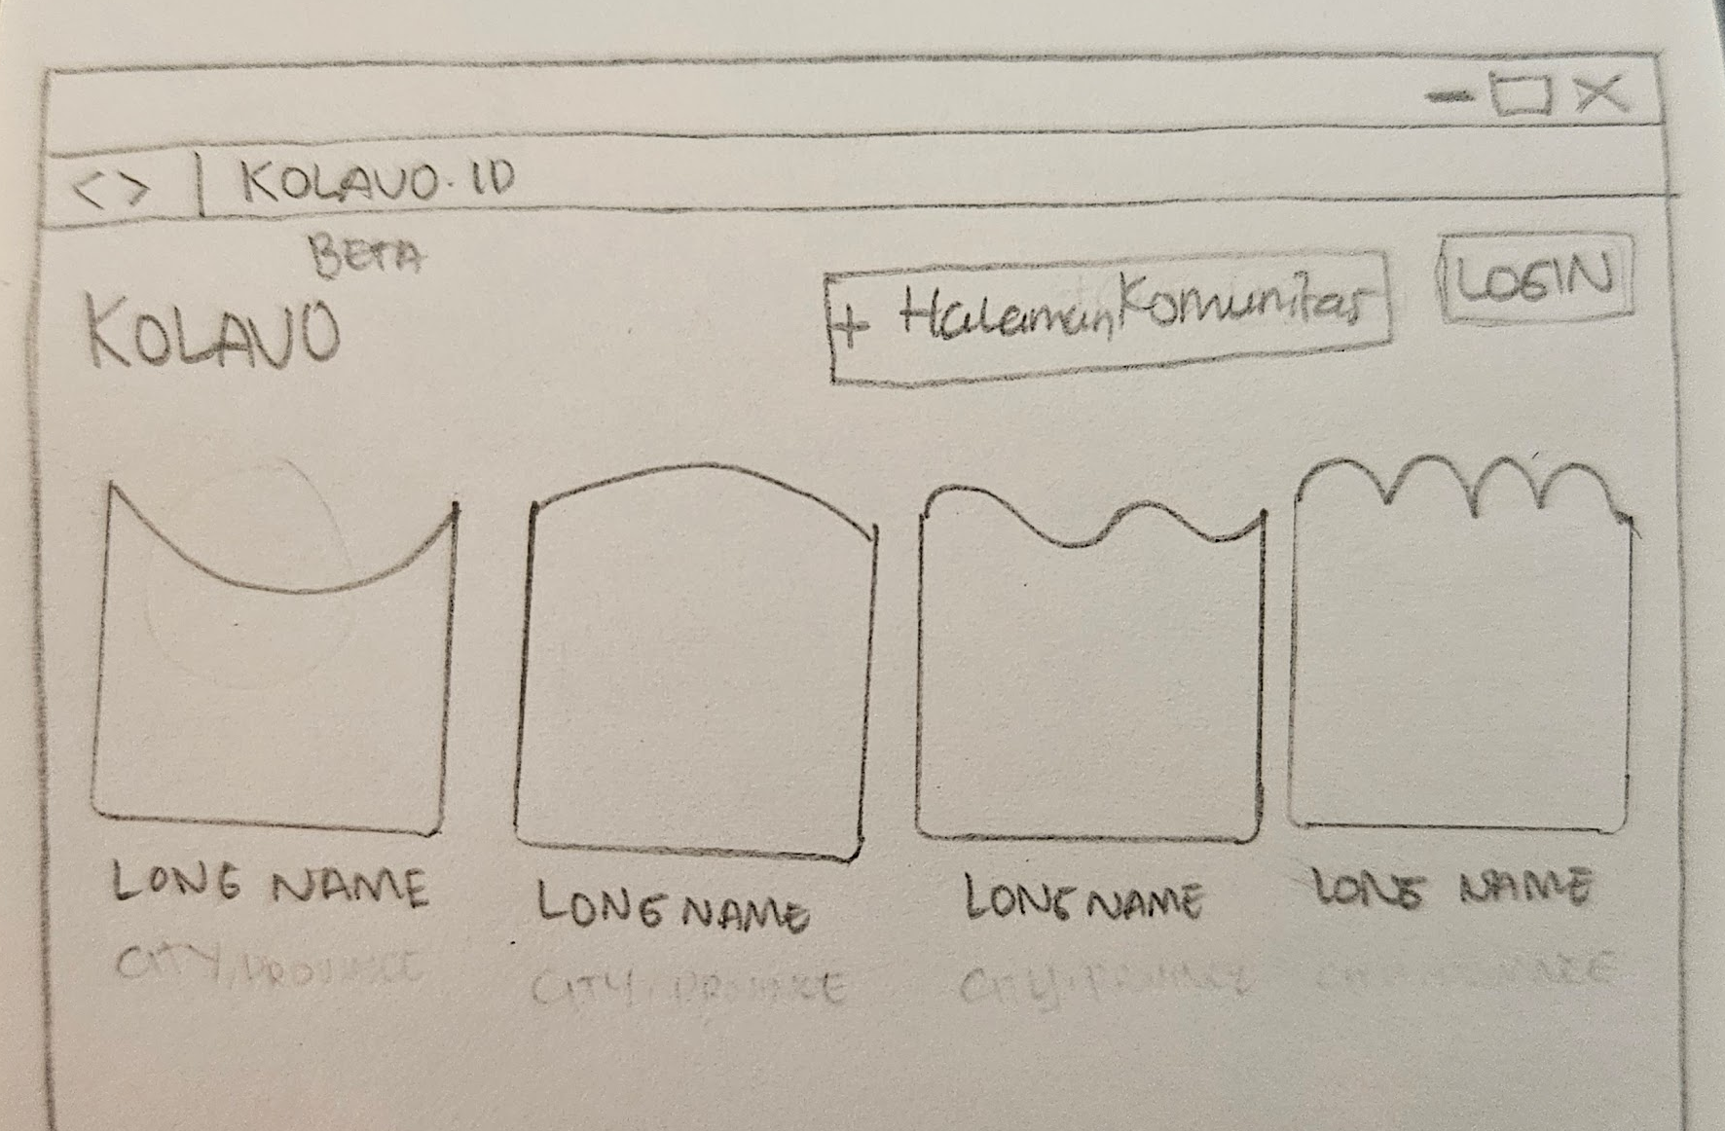
Community Page Sketch

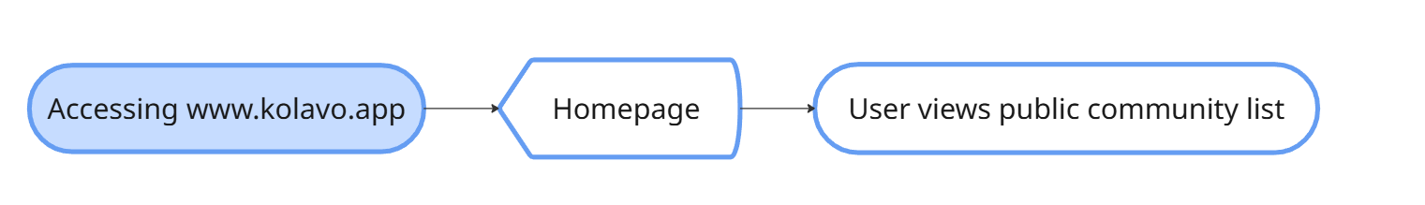
Viewing public community list flow

No. | User story | Scope | Acceptance Criteria
1 | As community organizers, I want to see what listed communities look like | Community directory visible to non registered users | All visitors who access Kolavo.id directed to homepage contains community directory
1 |  | Show fixed first-page display limit in home page | Each community position should not be fixed. It should be dependent on how much info within each community.
1 |  | Differentiables community identities | Showing:  - Logo  - Long name (5-10 words)  - Community logo without background color  - Community shortname  - Community longname  - Number of members with picture of the members (picture of admin and 2 other members who has photo uploaded).  - Domicile: city, country  - CTA: Lihat
2 | As community organizers, I want to see further information of listed communities | When a community clicked, opens community page | Community page opened has to be the same with community linked
3 | As community organizers, I want to create my own community profile | Create community button | - Easy to find  - User needs to have updated profile to create community page
4 | As community organizers, I want to access it on mobile phone when needed | Mobile responsive | - Looking tidy when accessing using mobile phone  - Have accessible menu
5 | As community organizers, I want to easily know where to update my profile | Account button | - Easy to find  - When clicked directs to user’s account page
6 | As visitors, I want to easily understand if this platform is for me. | Hero Section | Showing:  - Illustrations that describes Kolavo  - Headline  - Subheadline

Design Requirement

Homepage Header
Design Intent | Show Kolavo brand clearly and inviting users to login
Content / Copy | - Kolavo Logo  - Create community button: Buat Halaman  - Not logged in: Masuk  - Logged in but profile not updated: Akun  - Logged in and profile updated: Profile Picture
Visual Requirement
Interaction Behavior | - Mobile:  - When scrolling, header stays and the content scrolling behind  - PC:  - Scrolling the page hiding main header and showing nav bar which stays at the bottom in front of contents
Acceptance Criteria
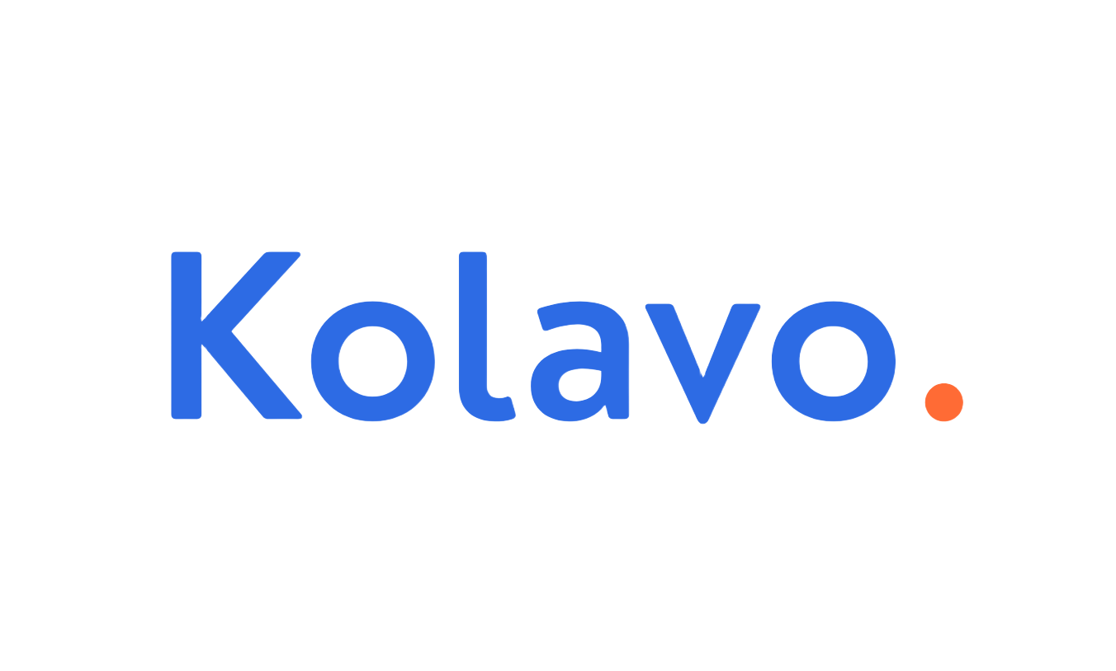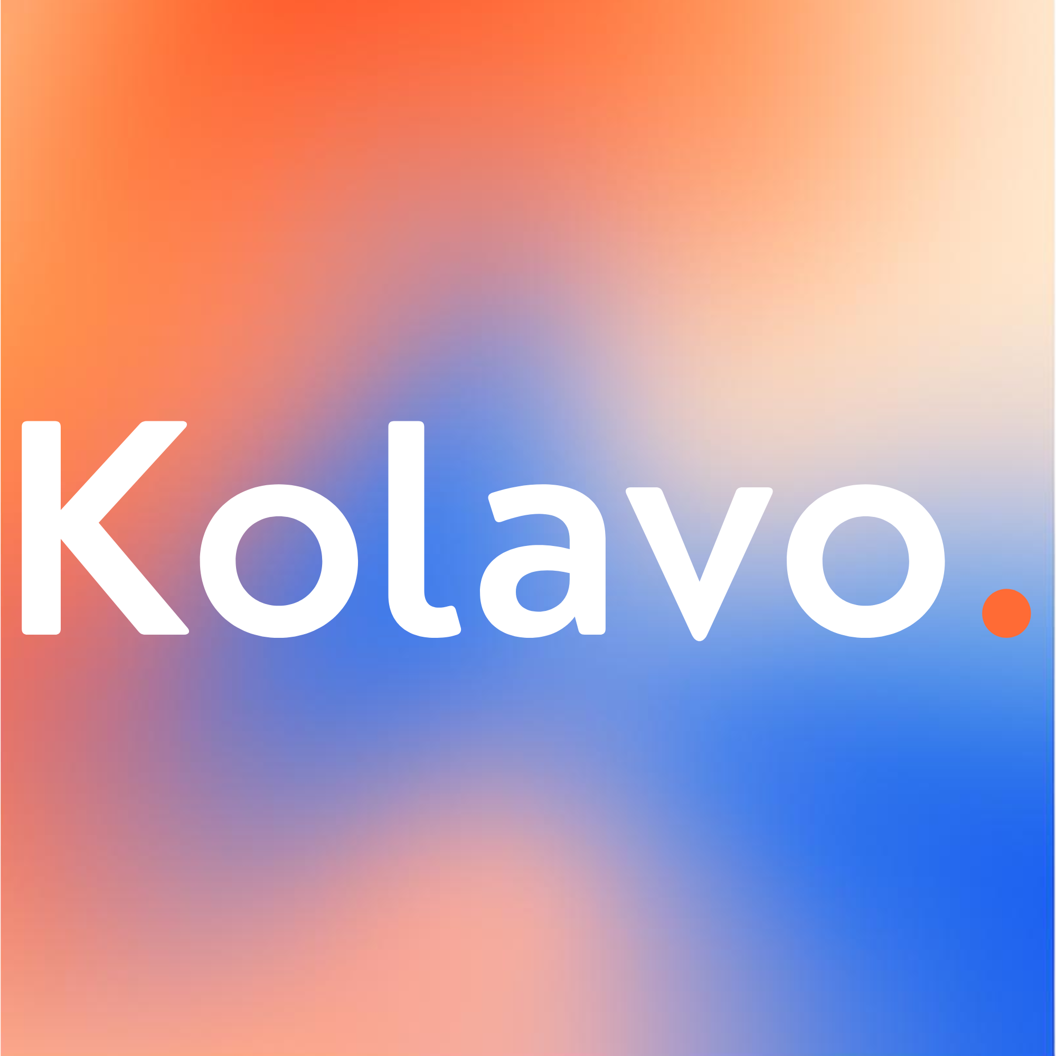
Kolavo Logo Kolavo Color

Hero Section
Design Intent | The hero section should encourage visitors to discover communities or create a new one.
Content / Copy | - Illustrations:  - Western Indonesian hijabi woman with fair skin color (at the middle)  - Chindo woman: white skin color, long straight hair  - Eastern man: brown skin color, curly short hair  - Headline: Mana Database Anggota Komunitasmu?  - Subheadline: Temukan dan bergabung ke komunitasmu atau buat yang baru. Karena tak kenal, maka tak kolab.
Visual Requirement
Interaction Behavior
Acceptance Criteria

Community Card
Design Intent | Community cards should be insightful at glance and inviting users to take a look.
Content / Copy | - Community logo without background color  - Community shortname  - Community longname  - Number of members with 3 pictures of the members and the rest total number  - Domicile: city, country  - CTA: Lihat
Visual Requirement | - Look balance between Kolavo community branding but community branding stronger when interact  - For picture of members, only show admin picture and 2 other members who uploaded photo, not default of initial.  - The colour accent in the card uses Kolavo colours and changes to community theme colour as:  - Mouse hover the card (pc)  - Tap the card (mobile)
Interaction Behavior
Acceptance Criteria

no. | Main color | Brightness | Degraded color
1 | 0D7FFD | +83 | #D6E9FF
2 | 2D6BE4 | +83 | #DCE6FA
3 | 31D9A5 | +83 | #DCF9EF
4 | 30AEE0 | +83 | #DCF1FA
5 | 30E04D | +83 | #DCFAE1
6 | 30D4E0 | +83 | #DCF8FA
7 | 4B0082 | +88 | #ECD1FF
8 | 895129 | +78 | #EED7C7
9 | CB30E0 | +78 | #F4D1F8
10 | DB462E | +77 | #F7D4CF
11 | E3269B | +77 | #F9CDE8
12 | EBC81E | +77 | #FAF3CB
13 | FD8A0D | +77 | #FEE4C7


Example of Community Organizations Logo

Bottom Navigation Bar (Mobile)
Design Intent | The homepage should remain easy and comfortable to access on mobile without losing the main actions.
Content / Copy | Showing three menus:  - Community List: Komunitas  - Create community page: Buat Halaman  - Account:  - Profile not updated: Akun  - Profile updated: Profile Picture
Visual Requirement
Interaction Behavior | - Directs to homepage when Komunitas button is clicked  - Directs to Create Community Page Form when Buat Halaman button is clicked if profile is updated, otherwise directs to profile page  - Directs to user account when Akun button is clicked
Acceptance Criteria

Engineering Requirement

Questions

